Project 2 Report

By: Seth Beckman, Travis McCormick

12/13/2022

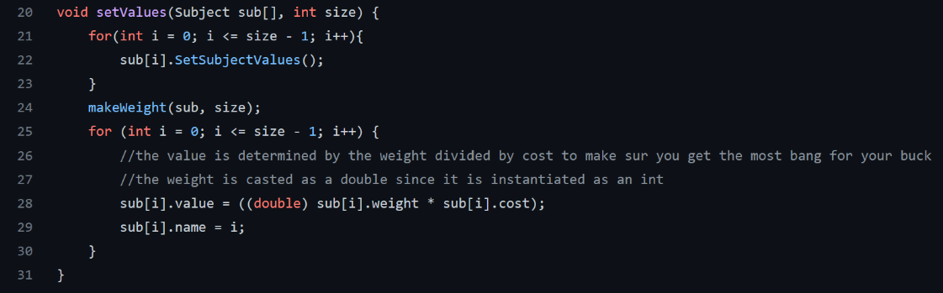

In these two functions we create and give a weight to each 100 vales. The weight is determined by how many phone are in its radius (all start at the weight 1) and then we take that weight and multiply it by the cost and that gives you the “valuableness”.

This then takes those values and sorts them from least to greatest using the quicksort method.

these functions are getting the total values and costs of all the phones. The level of coverage is the total area that all of the phones cover

This function uses the sort function to list them form least to greatest. Then it takes the most valuable and saves it in a separate array. Making sure that none of the phones are to close or that it goes over budget.

this function takes the cost of all the phones and sorts them based off of cost.

This is the same quicksort method but using cost instead of the “value” value.

UPDATED IN GITHUB

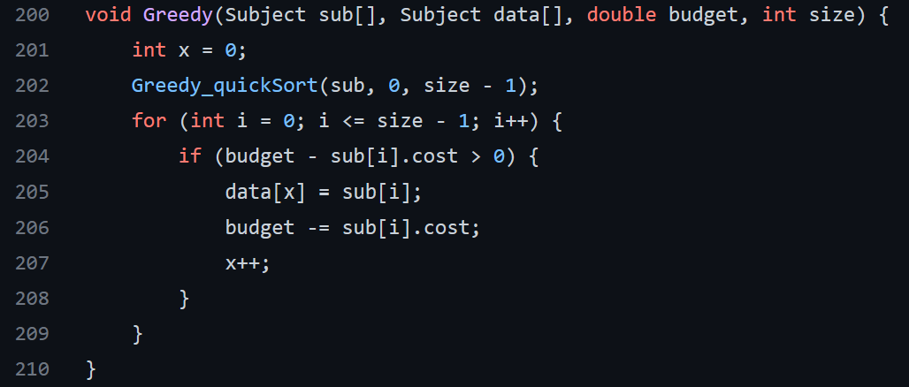

This take the sort for the Greed_quickSort and grabs the cheapest costing phones and puts them into a separate array. This does not care about distance because it only cares about grabbing the cheapest options. This is inefficient, as shown by running the code. Not only is it less than our algorithm but the level of coverage is greater than what the grid provides because Greedy algorithms only care about grabbing the least costing phones. This means that the information that it collects would be redundant and therefore useless

This randomly grabs different phones and puts it into a separate array. This does not care about distance either, it only makes sure that you don’t surpass the budget. This is inefficient, as shown by running the code. Not only is it less valuable than our algorithm, and sometimes less valuable than the greedy sort but the level of coverage is greater than what the grid provides because the random algorithms only randomly grab phones. It makes sure the budget is not exceeded but other than that if two phones are too close it doesn’t matter

this is inside our classes instead of having it in our constructor because inside the constructor it was setting value to everything when we just wanted certain things to have values and never everything have a value